CENWP-OD-B 05 July 2024

MEMORANDUM FOR THE RECORD

SUBJECT: 24BON018 MFR WA Shore AWS LPS RB1 and RB2 Pacific Lamprey Mortalities

On the morning of 05 July, Project Biologists discovered one adult Pacific Lamprey mortality in Rest Box 2 of the Washington Shore Auxiliary Water Supply LPS (WA Shore AWS LPS RB2) and four in the WA Shore AWS LPS Rest Box 1 (RB1). The fish were scanned for PIT tags, measured, inspected, and returned to the river.

1. WA Shore AWS LPS RB2
- Species – Pacific Lamprey (Entospehnus tridentatus)
- Origin – Unknown
- Length – 67.95cm
- Marks and tags – None
- Marks and Injuries found on carcass – Fungus, some abrasions to caudal fin that potentially could be mouth marks from other lamprey, and hemorrhaging from gill holes.
- Cause and Time of Death – Unknown
- Future and Preventative Measures – N/A
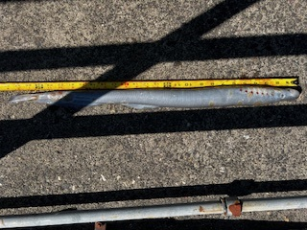

2. WA Shore AWS LPS RB1
A. Species – Pacific Lamprey (Entospehnus tridentatus)
B. Origin – Unknown
C. Length – In order from a to d: 64.14cm, 74.93cm, 72.39cm, and 72.39cm
D. Marks and tags – None
E. Marks and Injuries found on carcass – No injuries found, fungus on c. and d., hemorrhaging from gill holes on all fish.
F. Cause and Time of Death – Unknown
G. Future and Preventative Measures – N/A

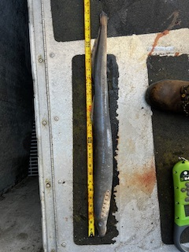
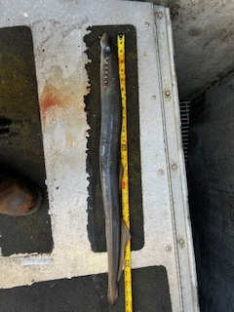
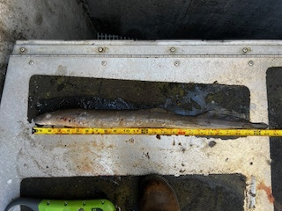
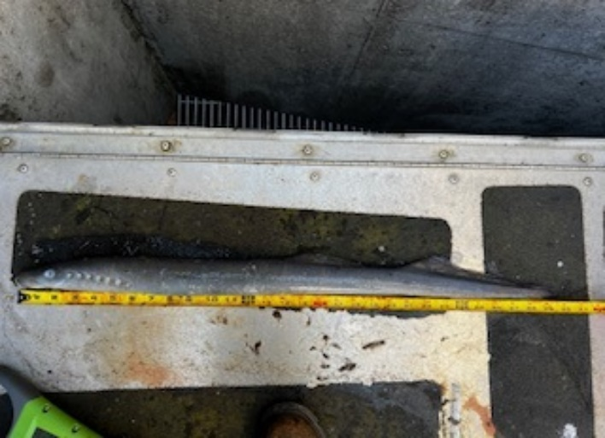
a. b.

c. d.

Sincerely,
Project Fisheries

